Web Engineering Project

Semester- W-17

**1st Phase – Static Version of Website**

Project Requirements

1. Project have five pages (HTML/CSS Version Responsive Layout)
   1. Home
   2. About Us
   3. Products
   4. Products Details
   5. Contact Us

Layout required as follows (Strictly follow the layout)

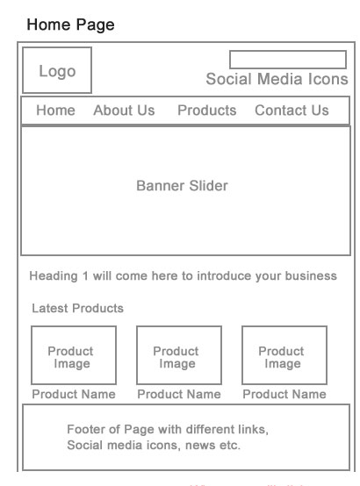

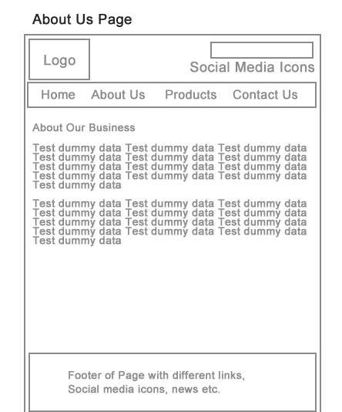

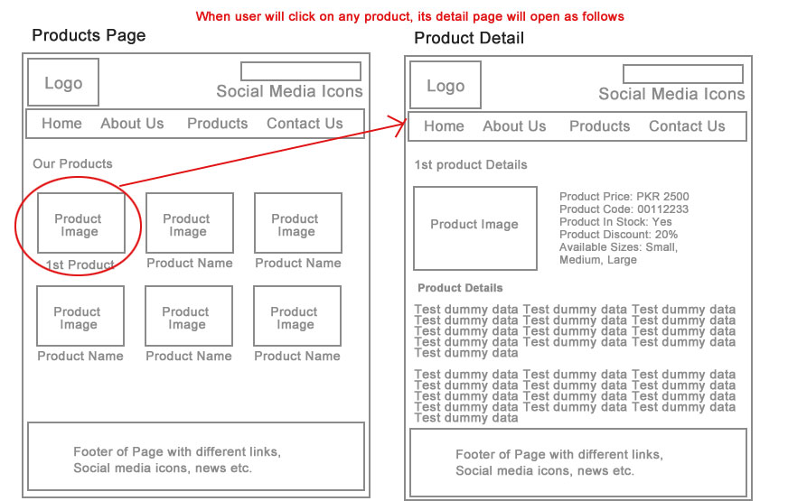

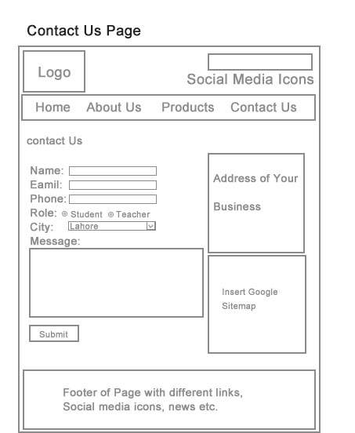

**2nd Phase – Dynamic Version of Website (Php+Mysql)**

You need to create three tables into database

**tblusers (Admin User)**

Fields required

userId (int )

username (varchar)

userpassword (varchar)

**tblproducts**

Fields required

productId (int)

productName (varchar)

productPrice (float)

productCode (varchar)

productInstock (boolean Y/N)

productDiscount (float)

productSizes (varchar)

productDetails (text)

**Following tasks need to be DONE**

1. Secure Login Area Management with help of SESSIONS for admin user
2. Admin should be able to perform CRUD operation on Products Module (Including Picture Upload Working)
3. The Products should be displayed (with Status “Y”) on Products Page and by clicking on any Product the Details of that Specific product should display on Product Details Page.

Deadlines are given in course log file.

**3rd Phase – Develop Above functionality in laravel**

All the work you have done in phase two, do repeat that with LARAVEL